COURSE: CLOUD AND NETWORK SECURITY _C1-2024
STUDENT NAME: LENNIE NTHIGA
STUDENT NO: cs-cns07-24170
NOVEMBER 20,2024

WEEK 9 ASSIGNMENT 1
Assignment 1: Key Vault and Encryption

Introduction
The activity would be the creation of key vault which is a like a secure box in which all the passwords, secretes and keys are stored managed and accessed this key vault also having a key that is managed by the administration in controlling the key vault. Here there was a deployment of resources which included a database that which an application in azure would be registered for the creation of credentials to access it as a service when feeding data from a program file that had data

Lab 07: Key Vault (Implementing Secure Data by setting up Always Encrypted)

Step1: Deploy the base infrastructure from an ARM template
We had access to az-500-10_azuredeploy.json template which contained the configurations and deployment of resources in the resource group AZ500LAB10 under Canada central region
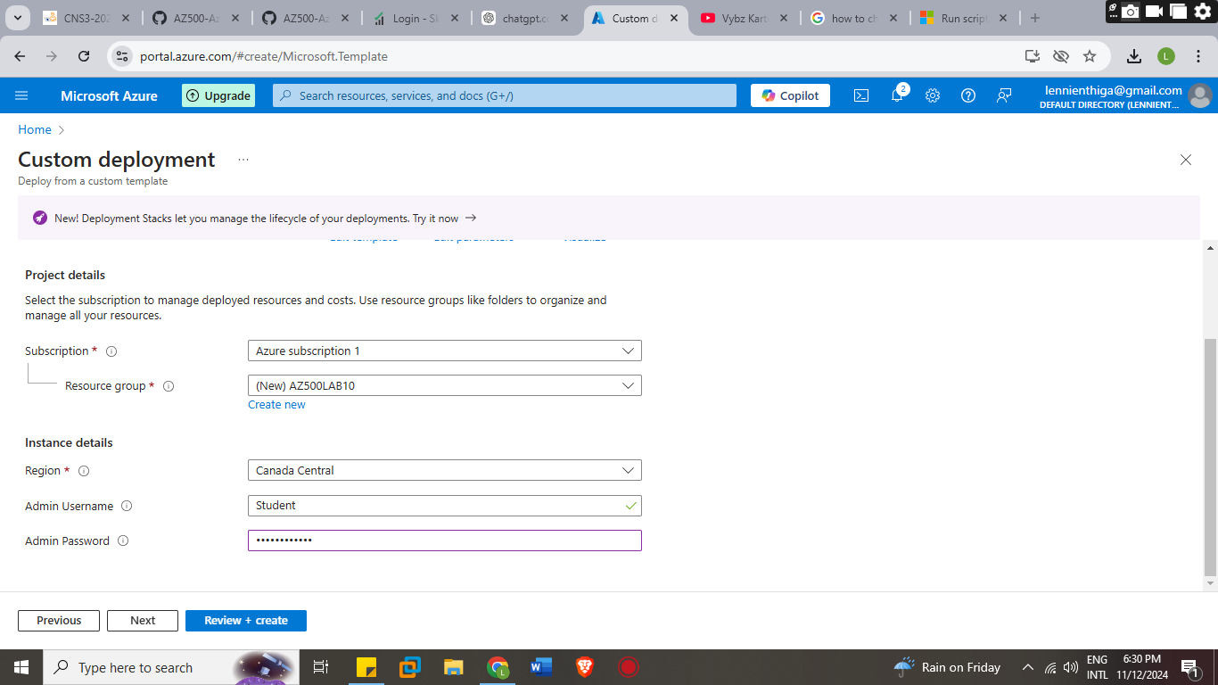
Which would have setup the following resources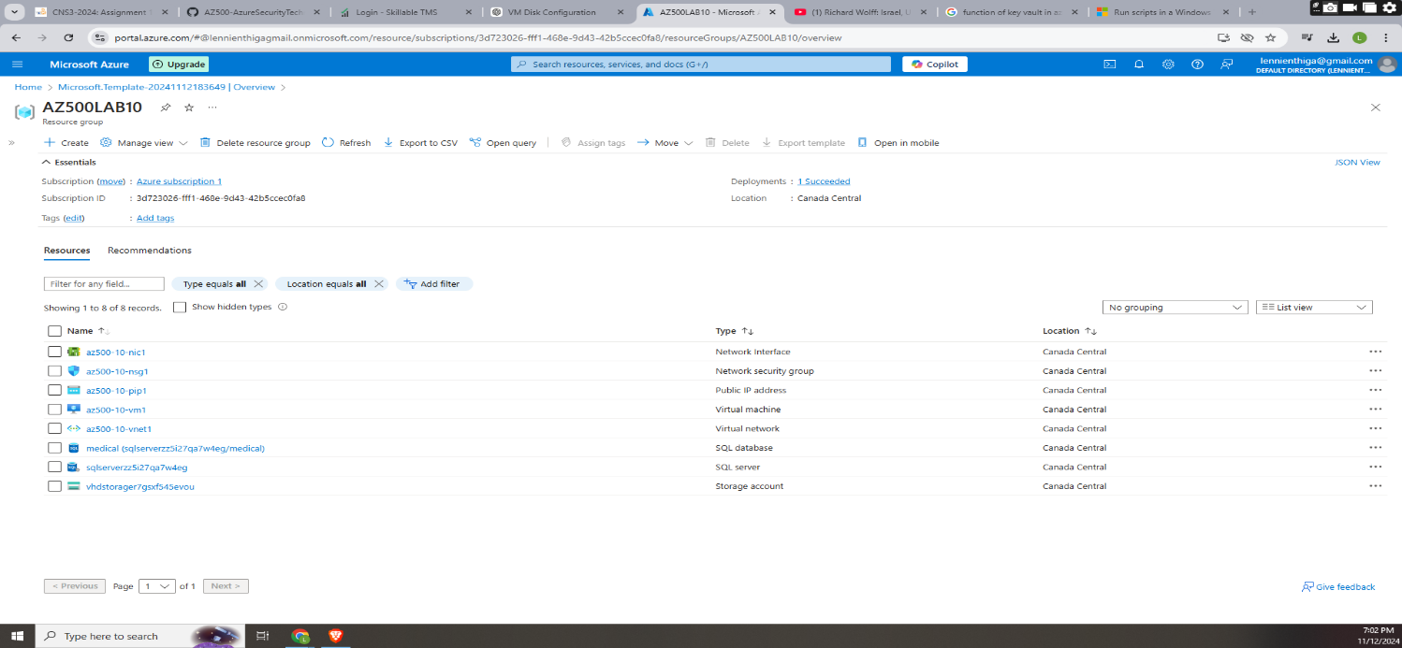

Step 2: Configure the Key Vault resource with a key and a secret
Task 1: Create and configure a Key Vault
Key vault is a location in which secures the passwords keys , secrets, encryption keys, and certificates of an organization resources
In the PowerShell we would run the commands
$kvName = 'az500kv' + $(Get-Random)
$location = (Get-AzResourceGroup -ResourceGroupName 'AZ500LAB10').Location
New-AzKeyVault -VaultName $kvName -ResourceGroupName 'AZ500LAB10' -Location $location -DisableRbacAuthorization
Which would be $kvName asa the variable name for name of the key vault which would be created with the first characters as az500kv followed by a randomly generated number for the location would be the region of the resource group and while the last command would be the one that would initialize the creation of the key vault
Task 2 creation of access policy
This is for the management and control to secrets, keys, and certificates stored within the vault. This defines which users, applications, or services can perform specific actions on the resources within a Key Vault.
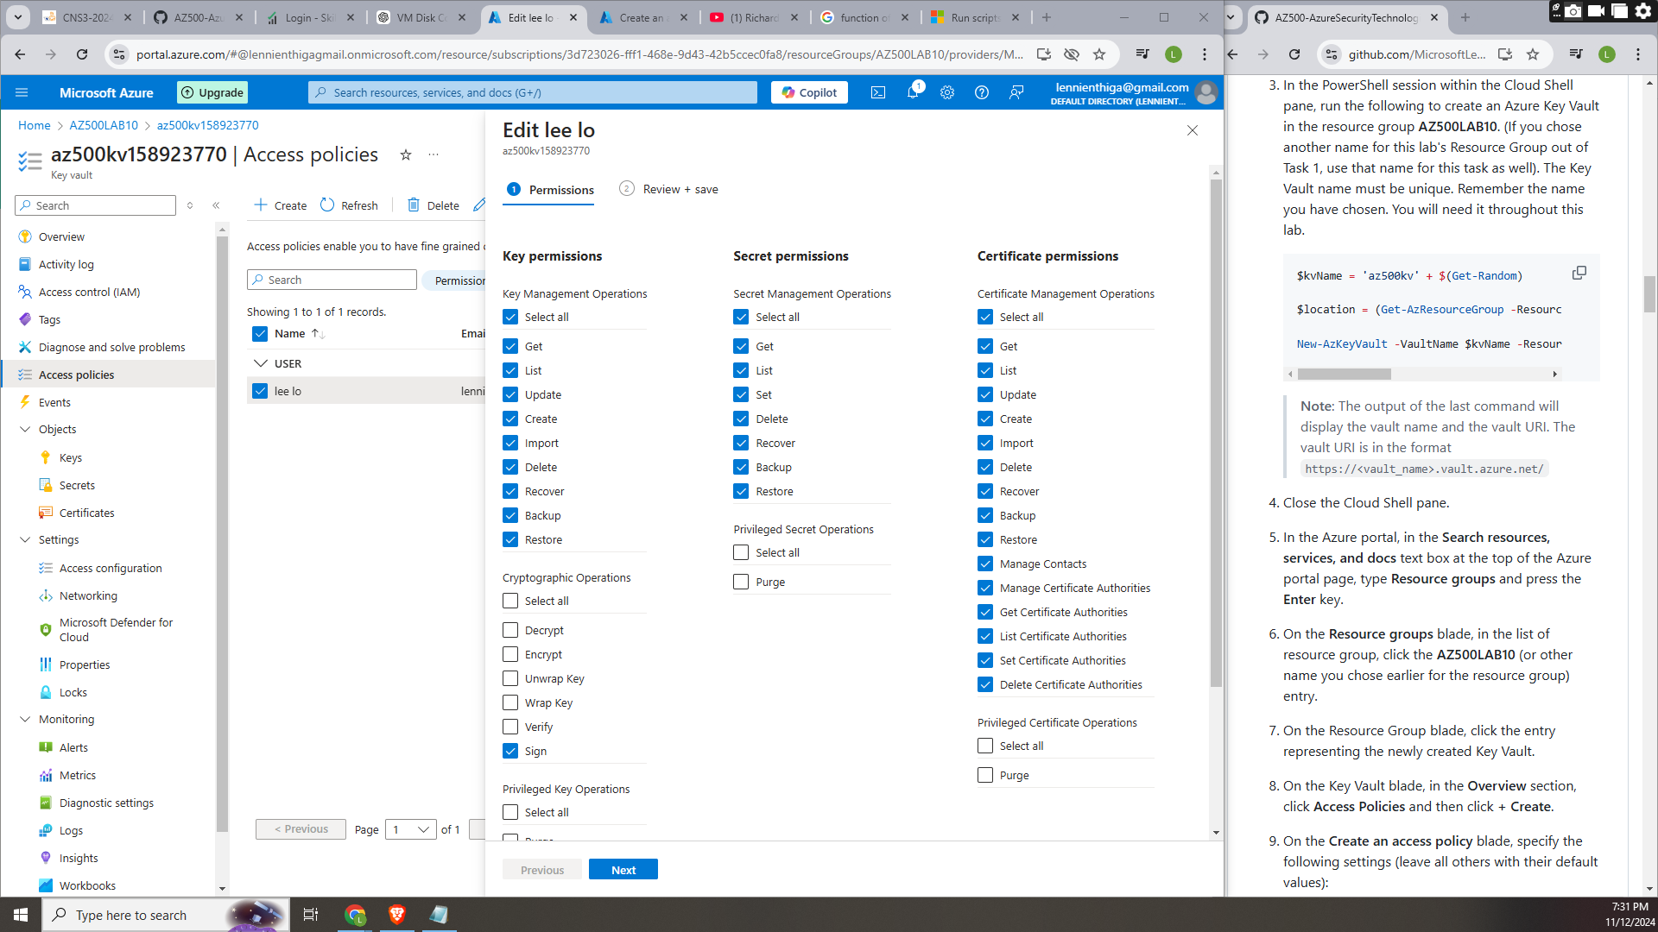

Task 3: Add a key-to-Key Vault
We would run the command
$kv = Get-AzKeyVault -ResourceGroupName 'AZ500LAB10'
$key = Add-AZKeyVaultKey -VaultName $kv.VaultName -Name 'MyLabKey' -Destination 'Software'
Get-AZKeyVaultKey -VaultName $kv.VaultName
Whereby the $kv is the variable name that would represent /fetch the key vault in the resource group AZ500LAB10 thus the $key would represent the adding of the key in the vault key in $kv with the name MyLabKey the last command initializing the setup of the key
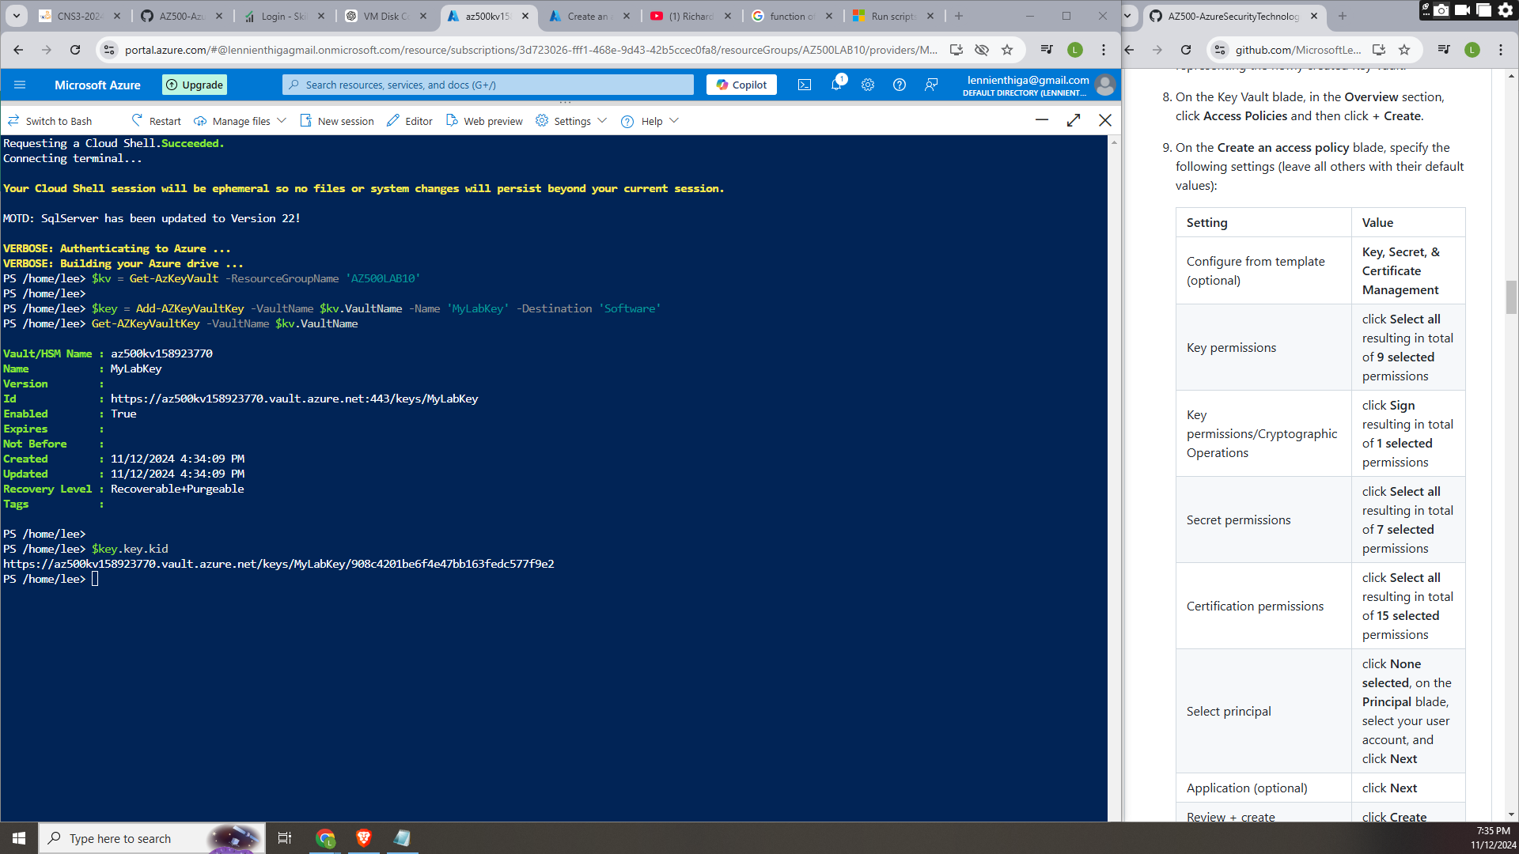

Task 4: Add a Secret to Key Vault
A secret is a sensitive data such as passwords Api keys , certificates hat would be stored in key vaults in this case it’s the SQL password
Was set up by running
$secret value = ConvertTo-SecureString 'Pa55w.rd1234' -AsPlainText -Force
$secret = Set-AZKeyVaultSecret -VaultName $kv.VaultName -Name 'SQLPassword' -SecretValue $secretvalue
Get-AZKeyVaultSecret -VaultName $kv.VaultName

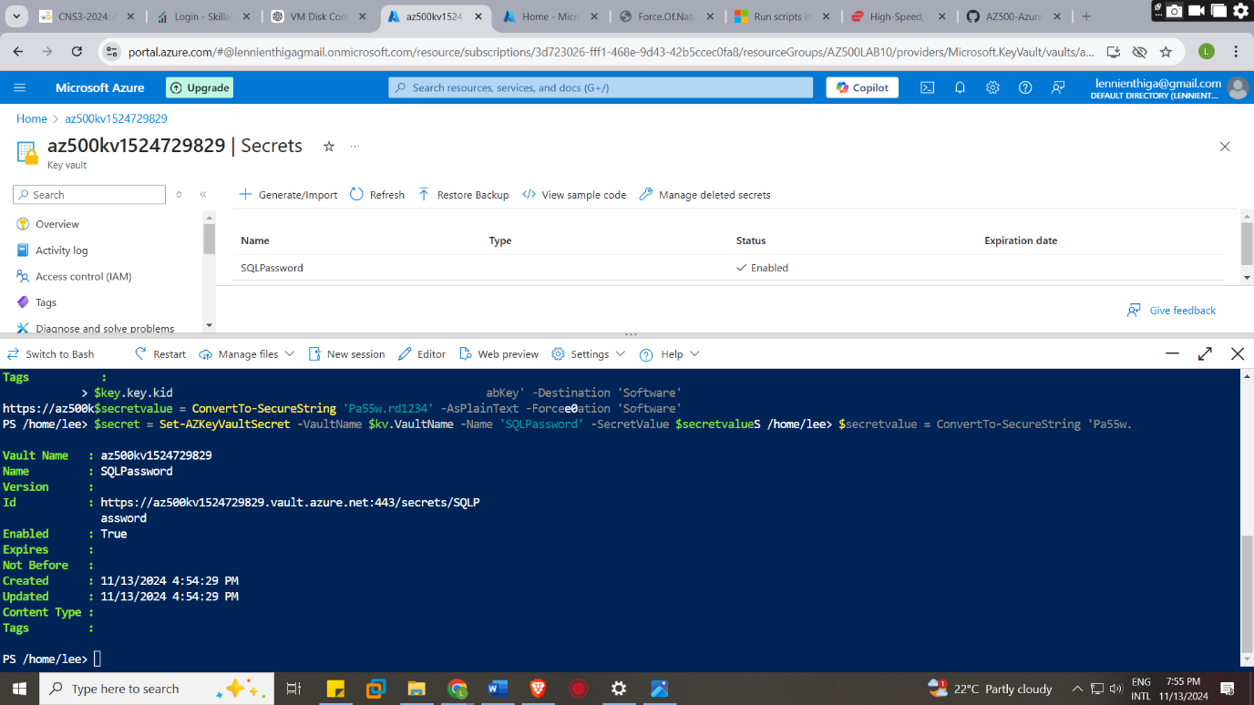

Step 3: Configure an Azure SQL database and a data-driven application
Task 1: Enable a client application to access the Azure SQL Database service.
We would be registering an application in azure and allocate it a key with an expiration date
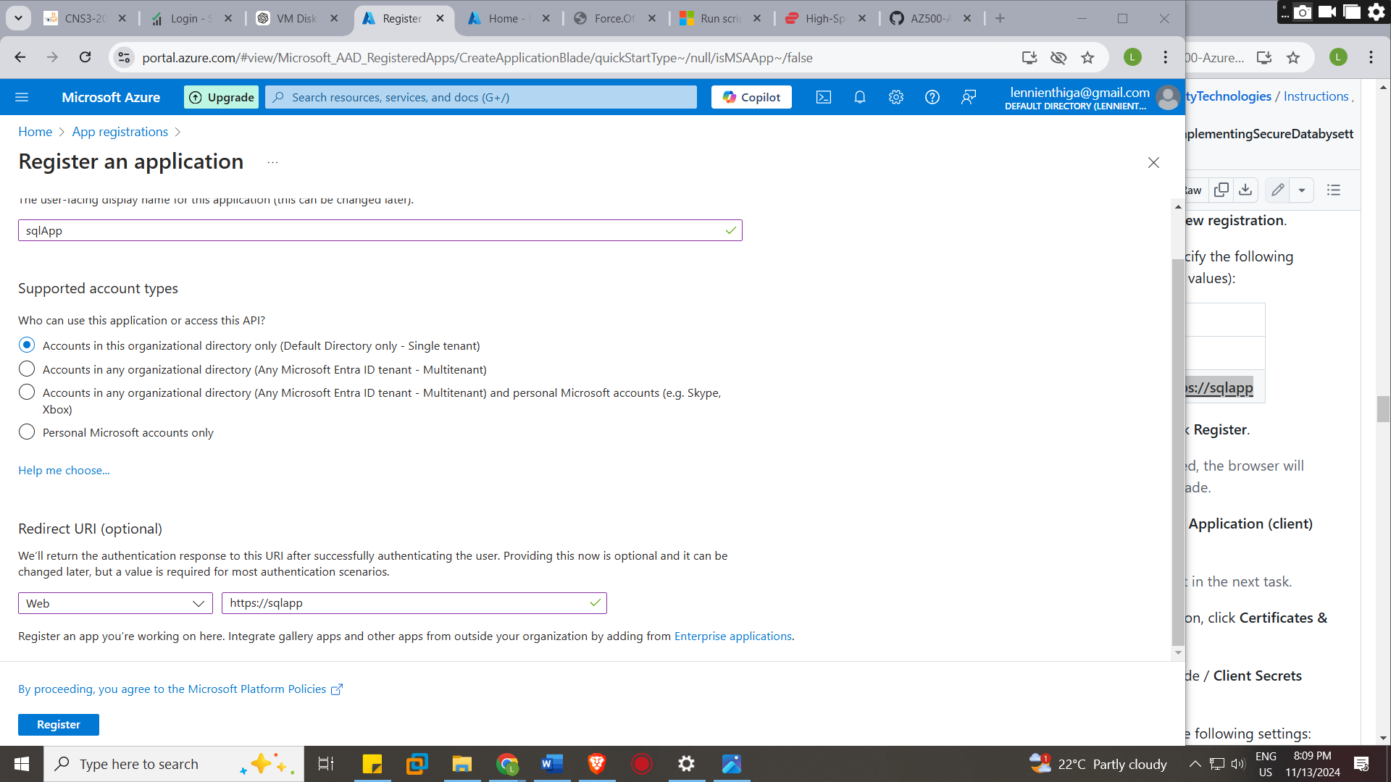

Task 2: Create a policy allowing the application access to the Key Vault.
This will grant the newly registered app permissions to access secrets stored in the Key Vault.
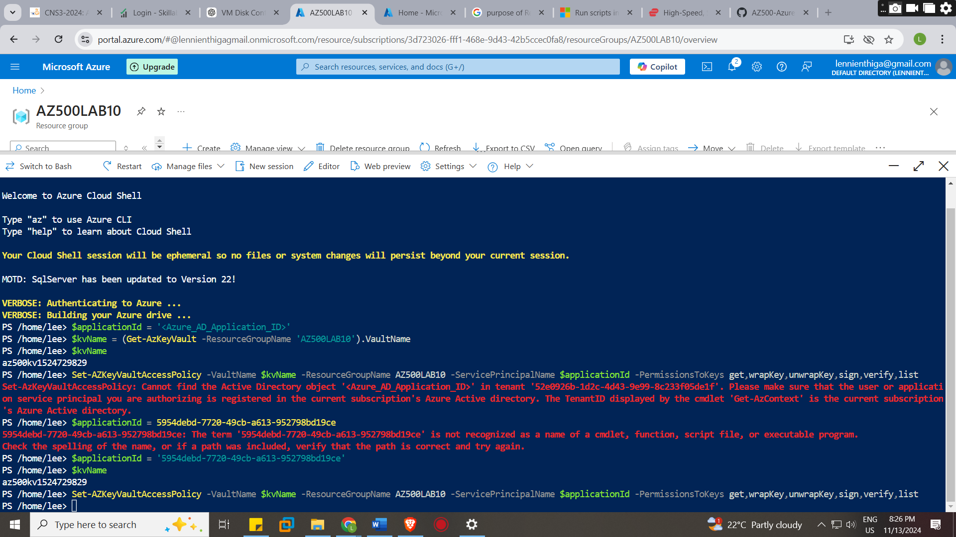

Task 3: Retrieve SQL Azure database ADO.NET Connection String
The ARM-template deployment in Exercise 1 provisioned an Azure SQL Server instance and an Azure SQL database named medical . You will update the empty database resource with a new table structure and select data columns for encryption
This would be located in the medial sql database at connections sting tab
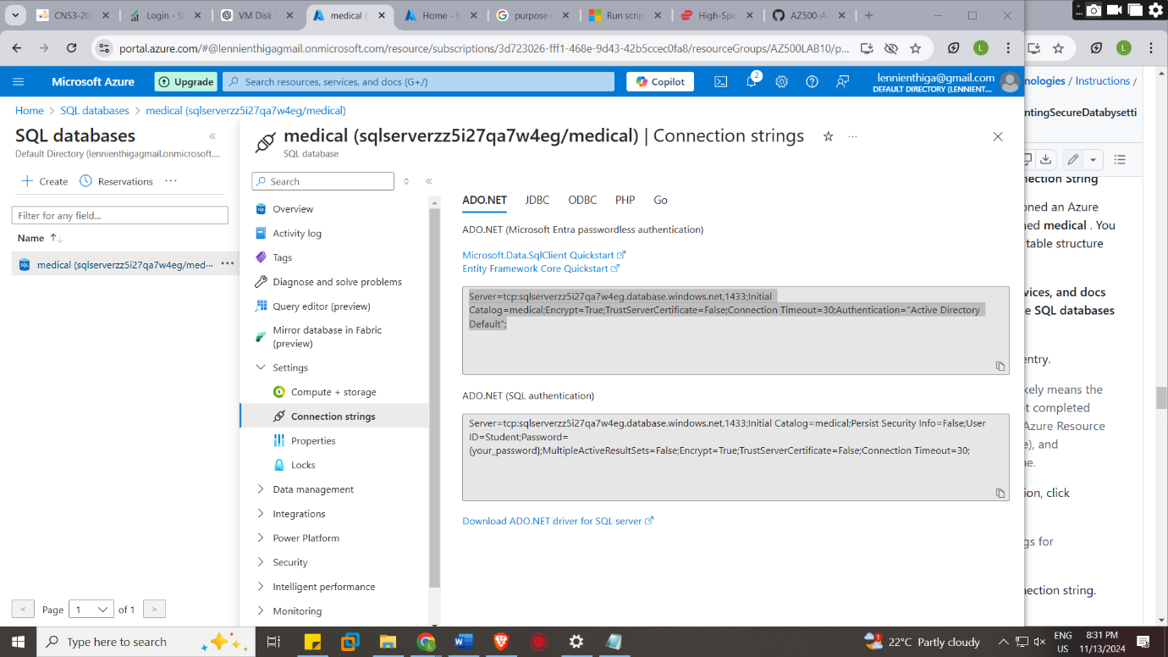

And note the Ip address of the vm which is 52.228.8.51
Task 5: Create a table in the SQL Database and select data columns for encryption
We added a sever firewall configured the firewall rule with the virtual machines public Ip
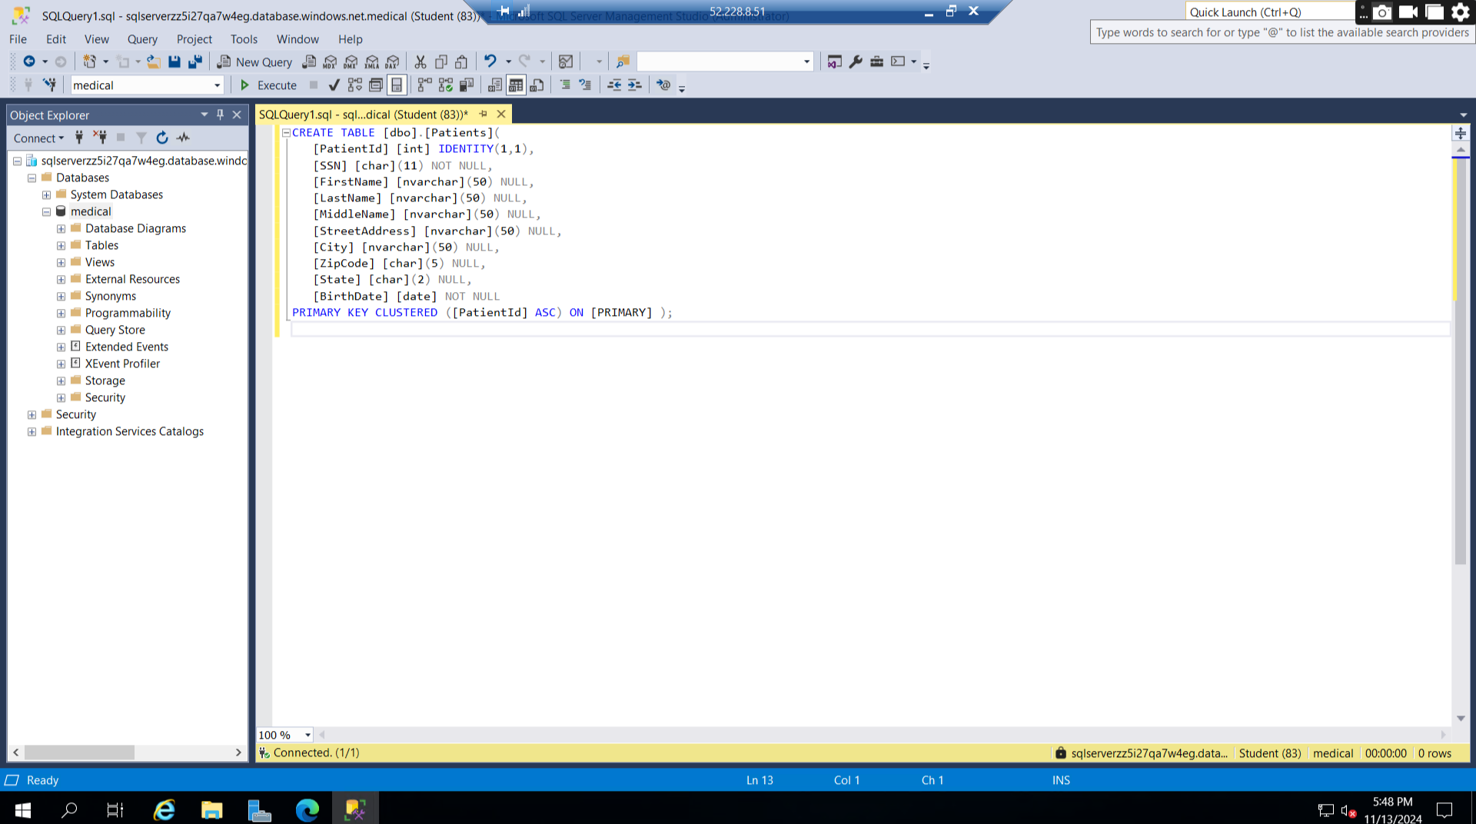
Downloaded the rdp file so as to connect the vm iso file which is windows operating system and connected the SQL server management studio to the SQL server using the credentials for the serve name medical in azure ad the logins credentials Which it provided the SQL database and made a table Patients and its collum and save.
We have to encrypt the desired collum with the stated types of encryptions
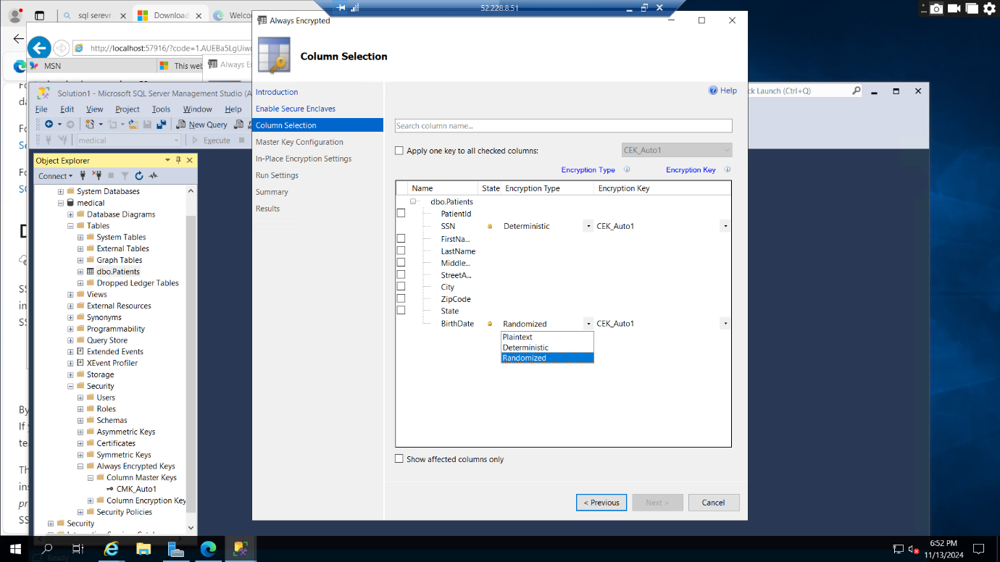

Master key setting by signing in to azure account used
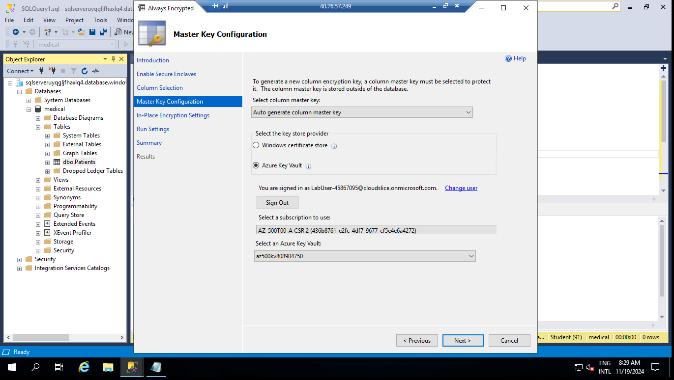
The image shows the successfulness of the encryption of birthdate and patient id with the connection of the SQL server managements to the azure key vault
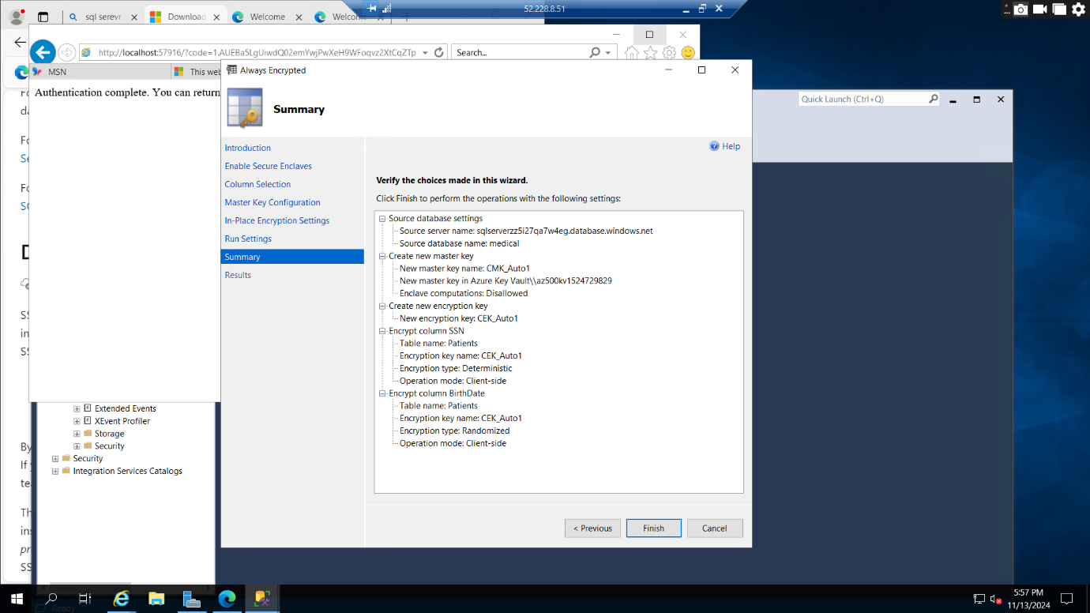
After the completion of encryption of the collum birthdate with randomized encryption
and son with deterministic encryption
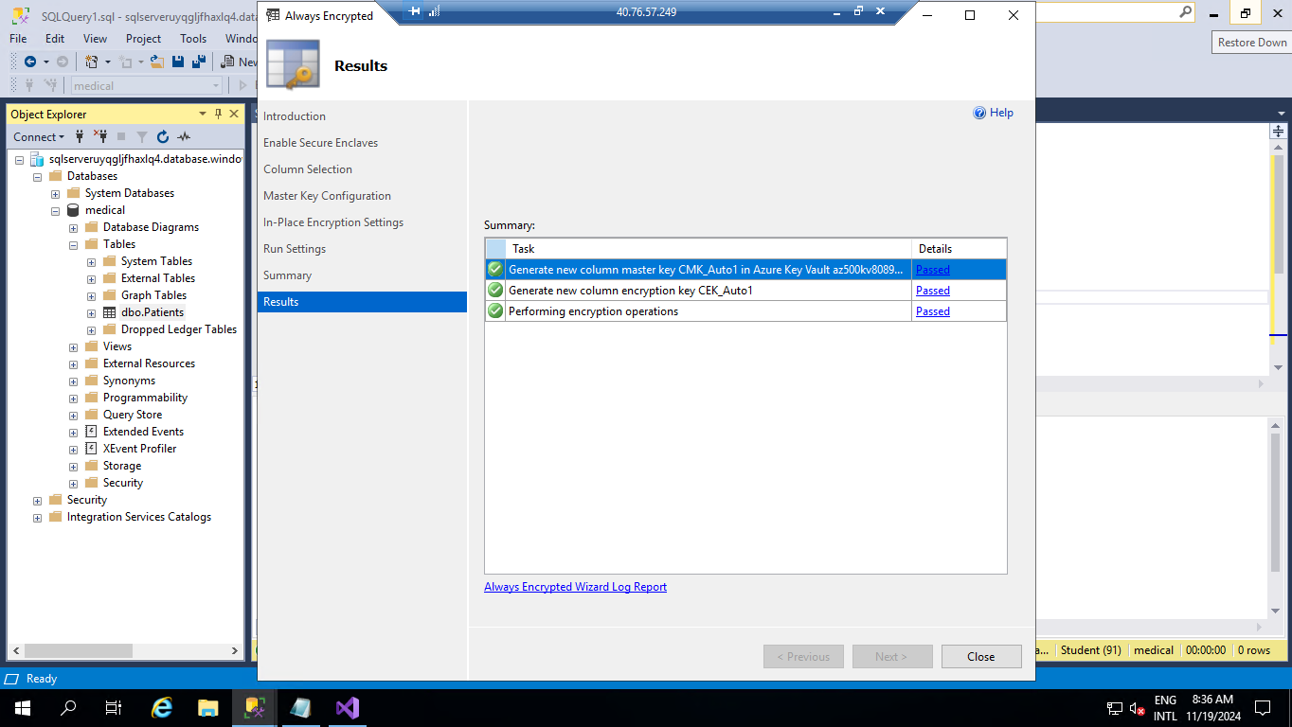

Step 4: Demonstrate the use of Azure Key Vault in encrypting the Azure SQL database

Task 1: Run a data-driven application to demonstrate the use of Azure Key Vault in encrypting the Azure SQL database
Running the visual studio application and create a project template for Console App (.NET Framework) for C# with the name and solution name Open Encrypt
After the creation of the project, I installed the packages with the NuGet package consoler in the tool bar
Of which would generate the solution explorer on the left with the file Proram.cs where we would paste the program file, we got from the resources this program having contained sample data that the SQL would be fetching from
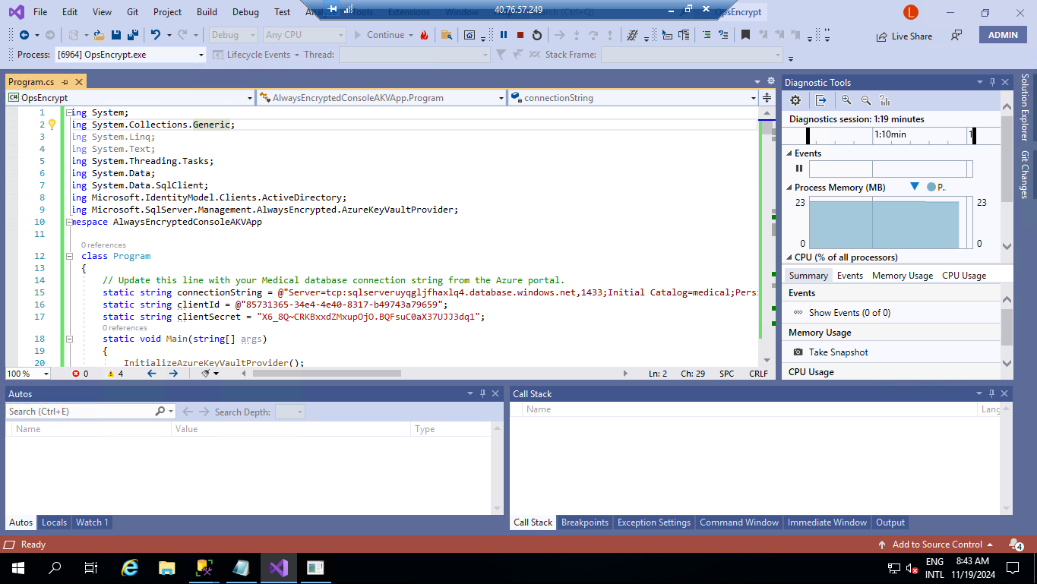
On line 15 I pasted the connection string for ADO.NET and replaced the password with the password I had and line 16 the parameter for client id was replaced with the value for the key and line 17 was filled with the application client id and runed
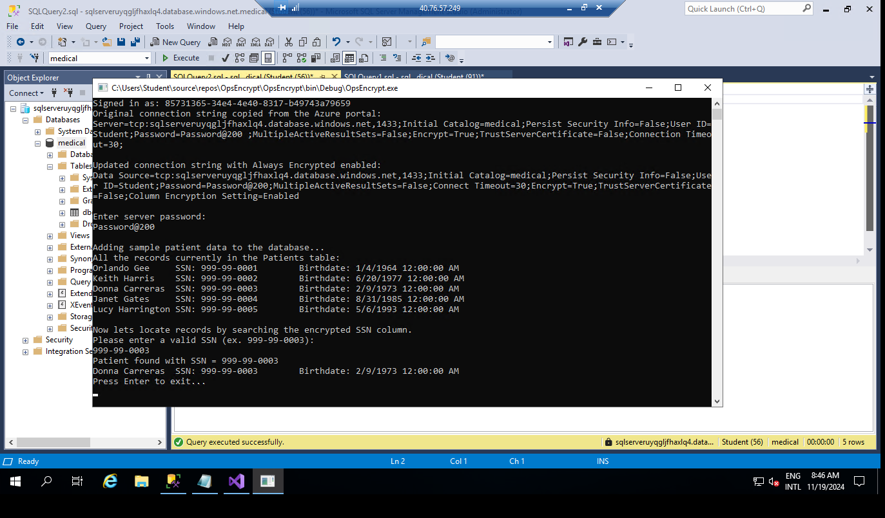

On the SQL database I run a query SELECT FirstName, LastName, SSN, Birthdate FROM Patients;
to get the collum and check if the SSN and birthdate would be encrypted of which they were
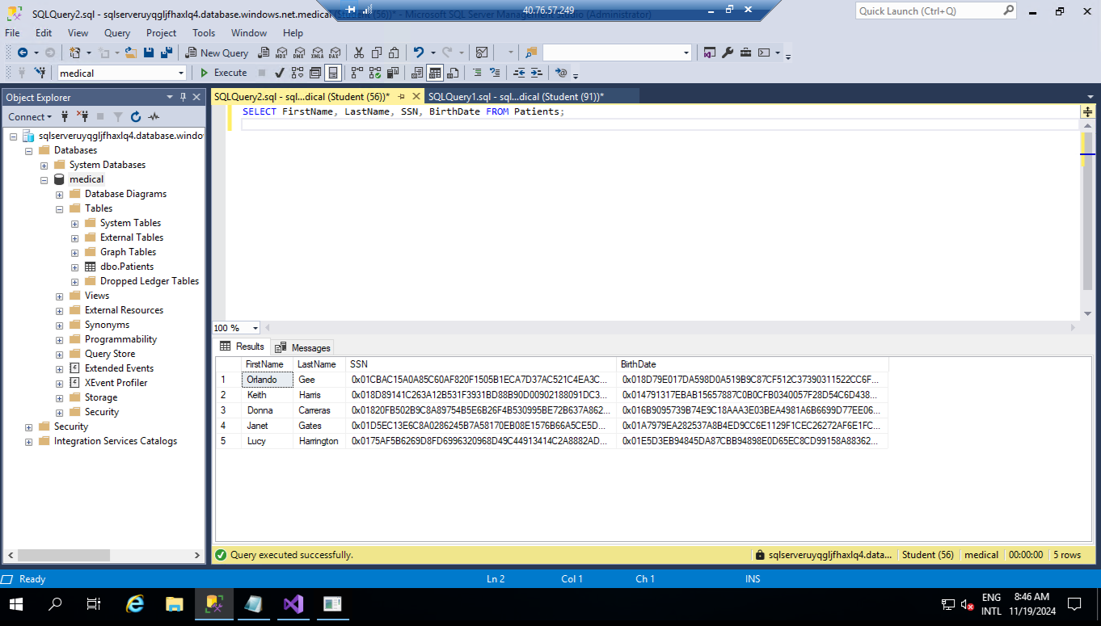

From this point the lab is complete and the resources would be deleted
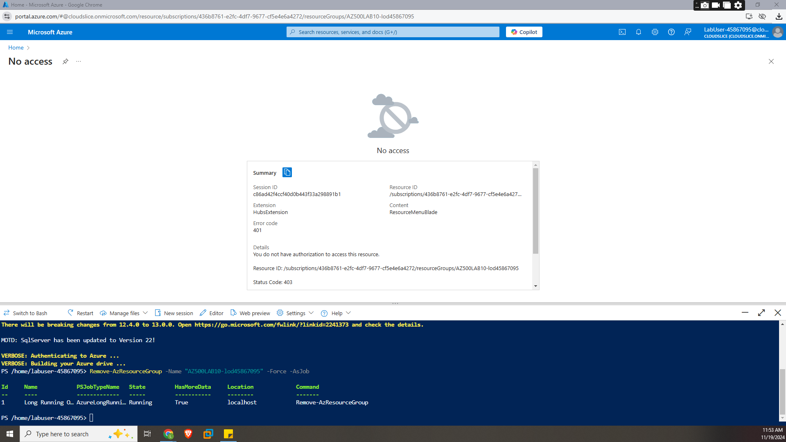

Conclusion:
This exercise has displayed a number of layers of security within the requesting of data with a query in SQL management system that is from the registration of an application to get the credentials to use the services which is the medical database providing a value name and secret id, the creation of key vault that would store the applications credentials and key for the key vault and the encryption of the database collum

